

**Mathematics Applications  
YEAR 12**

**Investigation 2 – Pascal’s Networks**

**Semester 1 2018**

**Time allowed:** One week (In-Class assessment Friday Week 6)

**Marks Available:** This section will not be marked. Research only

**Task:**

Research and familiarise yourself with Pascal’s Triangle focusing on its formation and patterns.

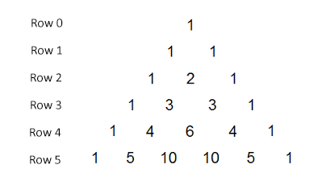

The In-class assessment will be conducted ‘note-free’. No research may be taken into this assessment. You will be able to utilise a scientific calculator only during the assessment; A ClassPad will not be allowed.